

A
Project Report On
“Vehicle Registration System”

A project Report submitted
In partial fulfillment of the requirements for the award of the degree of

Bachelor of Computer Application (B. C. A.) Submitted by
Chetan Manojsinh Suraswal
Lucky Pradip Madavi

Under the supervision of
Asst. Prof. Shantanu W. Mustilwar
VIDYA BHAVAN COLLEGE OF MANAGEMENT AND RESEARCH, YAVATMAL (MAHARASHATRA – 445001) INDIA, MARCH 2026

VIDYA BHAVAN COLLEGE OF MANAGEMENT
AND RESEARCH, YAVATMAL

Certificate
This is certify that project report entitled
Vehicle Registration System
Is completed by Chetan Manojsinh Suraswal and Lucky Pradip Madavi in satisfactory manner as a practical fulfillment for the completion of Bachelor of Computer Application- III (SEM VI) in Sant Gadge Baba Amravati University, Amravati and Vidya Bhavan College of Management and Research, Yavatmal-445001, during acdemic Year 2025-2026.

H. O. D.

Asst. Prof. Shweta Uplenchwar

Project Guide

Asst.Prof. Shantanu W.Mustilwar

Principal
Dr.Dhananjay Gaikawad



Internal Examiner External Examiner
Date:- / / 2026 Place:- Yavatmal

ACKNOWLEDGEMENT
On the completion of this project, I wish to great fully acknowledgement, by taking this opportunity to express my sincere gratitude to Asst. Prof. Shweta Uplenchwar Head of Department of Bachelor of Computer Application, for giving me kind support and incomparable guidance. Also thanks to my Principal Dr. Dhananjay Gaikwad for providing their computer resources and their coorporation.
I also wish to thank Asst.Prof. Shantanu W. Mustilwar (Project Guide), for guidance and useful suggestions that proved very useful in this project. Once again thanks to all the people who have directly or indirectly help in this project.
Lastly, we sincerely thanks to all my friends who have always given their encouraging support and been a great help all the time at various stage of development this project.

Chetan Manojsinh Suraswal
Lucky Pradip Madavi
BCA III YEAR SEM:VI 2025-2026

CANDIDATE’S DECLARATION
I hear by declare that the work presented in this project report title, “Vehicle Registration System” submitted by me in the partial settlement of the requirement of the award of the degree of Bachelor of Computer Application (B.C.A) submitted in the Department of Computer Science, Vidya Bhavan College of Management and Research Yavatmal, is an authentic record of my project work carried out under the guidance of Asst. Prof. Shantanu W. Mustilwar (VBCMR, Yavatmal)

Chetan Manojsinh Suraswal
Lucky Pradip Madavi
BCA III YEAR SEM:VI
2025-2026

Project Guide Head of Department Asst.Prof. Shantanu W. Mustilwar Asst. Prof. Shweta Uplenchwar
VBCMR, Yavatmal VBCMR, Yavatmal

SUPERVISOR’S DECLARATION
It is to certify that the project and entitled “Vehicle Registration System” which is being submitted by team members to the Vidya Bhavan College of Management and Research Yavatmal, in the fulfillment of the requirement for the award of the degree of Bachelor of Computer Application(B.C.A) is a record of “Vehicle Registration System” project work carried out by him/her /them under my/our guidance and supervision.

Chetan Manojsinh Suraswal
Lucky Pradip Madavi
BCA III YEAR SEM:VI
2025-2026

Project Guide Head of Department Asst.Prof. Shantanu W. Mustilwar Asst.Prof. Shweta Uplenchwar
VBCMR, Yavatmal VBCMR, Yavatmal

TABLE OF CONTENTS

Sr.No. | Name of the Chapter | Page No.
 | Acknowlwdgement
 | Candidate’s Declaration
 | Supervisor’s Declaration
 | Abstract | 1-2
 | Synopsis | 3-6
1 | Introduction | 7
 | 1.1 System Study | 8
 | 1.2 Objective of the Project | 9
 | 1.3 System Analysis | 10
 | 1.4 Existing System | 11
 | 1.5 Proposed System | 12
 | 1.6 Hardware and Software Specification | 13
2 | Analysis Design | 14
 | 2.1 Data Flow Diagram | 15-17
 | 2.2 Entity Relationship Diagram | 18
 | 2.3 Database Table | 19

3 | Design Documents | 20-25
4 | System Testing And Implementation | 26-27
5 | Future Scope And Limitation | 28-29
6 | Conclusion | 30-31
7 | Reference And Bibliography | 32-33

ABSTRACT

ABSTRACT

“The Vehicle Registration System is a software-based application developed to simplify and manage the process of vehicle registration in an efficient and systematic manner. The main aim of this project is to
replace the traditional manual method of maintaining vehicle records with a computerized system.

This system helps in storing, updating, and managing vehicle and owner information in a structured digital format. It allows authorized users to register vehicles, view vehicle details, and maintain accurate records. By using this system, data redundancy is reduced, record management becomes easier, and the chances of
human error are minimized.

The Vehicle Registration System is designed as a standalone application that works without internet dependency. It provides better security, faster access to records, and improves overall efficiency in vehicle
data management. This project is useful for organizations or offices that need a reliable and organized system for handling vehicle registration information.

Keywords: Vehicle Registration System, Standalone Software Application, Vehicle Data Management, Owner Information Records Digital Registration Process, Secure Data Storage.

SYNOPSIS

SYNOPSIS

Introduction:
In earlier times, vehicle registration and record maintenance were done manually using paper
files and registers. This traditional method required a lot of time, physical effort, and storage
space. Searching, updating, or verifying vehicle records was difficult and often led to errors,
data loss, or duplication of information. With the increase in the number of vehicles, the manual
system became inefficient and unreliable. Therefore, there is a strong need for a computerized
vehicle registration system that can store and manage vehicle data accurately. A digital system
helps in improving efficiency, reducing human errors, and providing quick access to vehicle
and owner information. This system ensures better record management and supports
smooth administrative operations.

Background:
The Vehicle Registration System Application is a standalone software application developed
to handle vehicle registration and record management in an efficient and organized manner.
The main purpose of this system is to provide a computerized solution for storing and managing
vehicle and owner information securely.

This application maintains a centralized database where all vehicle-related details such as
registration number, vehicle type, owner details, and registration status are stored. It allows
authorized users to add new records, update existing information, and retrieve vehicle details
whenever required. The system ensures data accuracy by reducing manual entry errors and
maintaining consistency in records. Since the application works as an offline standalone system,
it does not depend on internet connectivity and provides faster access to information. It also
improves data security by restricting access to authorized users only. Overall, the Vehicle
Registration System Application helps in improving efficiency, reliability, and transparency
in vehicle registration management.

Problem Statement:
Vehicle registration authorities are responsible for maintaining accurate records of vehicles and their owners to ensure legal compliance, road safety, and efficient administration. However, managing vehicle registration data using traditional and partially manual systems creates several operational challenges. Many offices still rely on paper forms, disconnected databases, or outdated software, which slows down the process of vehicle registration, verification, and record management.

- Manual Data Entry and Paperwork: Many registration offices still depend on physical forms and manual entry of vehicle details such as owner information, vehicle number, engine number, and chassis number. This process is time-consuming and increases the chances of human error, duplicate entries, and incomplete records.

- Lack of Real-Time Updates: Updates regarding newly registered vehicles, ownership transfers, or status changes are often not reflected instantly in the system. This delay can cause confusion for administrators and users when verifying vehicle details or processing registrations.

- Fragmented Data Storage: Vehicle records may be stored in different files, spreadsheets, or systems, making it difficult to maintain a centralized database. Retrieving information about a specific vehicle or owner becomes inefficient, especially when historical records are required.

- Inaccurate Resource Management: Without a proper digital system, searching for specific vehicle details can take significant time. Administrators may need to manually check multiple records, which slows down the workflow and reduces operational efficiency.

- Limited Reporting and Data Analysis : Traditional systems do not provide automated reports or analytics regarding vehicle registrations, trends, or statistics. As a result, authorities cannot easily monitor registration patterns, vehicle distribution, or generate meaningful reports for planning and decision-making.

- Security and Compliance Risks: Vehicle registration data includes sensitive information such as personal details of vehicle owners and official registration records. Manual or poorly secured systems lack strong security features like authentication, role-based access, and secure storage, making the data vulnerable to unauthorized access or accidental loss.

Objective & Scope:

- Efficient Vehicle Registration: The primary objective of the Vehicle Registration System
is to provide a systematic and computerized method for registering vehicles. It helps in
maintaining proper records of vehicles and owners in an organized manner.

- Accurate Data Management: The system aims to store and manage vehicle details
such as registration number, vehicle type, owner information, and registration date accurately.
This reduces manual errors and improves data reliability.

- Quick Access to Records: One of the main objectives is to enable fast retrieval of
vehicle information whenever required. Authorized users can easily search and view
registered vehicle details without delay.

Scope :
- Vehicle Registration and Record Management: The scope includes registering new
vehicles, updating vehicle details, and maintaining complete records of registered vehicles
in a digital format.
- Owner Information Management: The system manages owner-related details such as
name, address, and contact information, ensuring proper linkage between vehicles
and their respective owners.
- Offline Standalone Operation: The Vehicle Registration System works as a standalone
application without internet dependency, making it suitable for offices with limited connectivity.
- Data Maintenance and Reporting: The system supports proper maintenance of vehicle
data and helps in generating required reports for administrative and verification purposes.

INTRODUCTION

  - System Study
The Vehicle Registration System is designed to provide a structured, efficient, and accessible for managing vehicle registration records using digital technology. The system aims to overcome the limitations of traditional registration methods that rely heavily on manual paperwork and disconnected data storage. In many cases, vehicle registration details are maintained through paper files or basic spreadsheets, which leads to delays, difficulty in retrieving records, and a higher chance of errors. With the proposed system, administrators can easily add, update, and manage vehicle information through a centralized digital interface, ensuring that records are organized and easily accessible.
This system aims to simplify the process of storing and managing vehicle registration data while improving the overall efficiency of record handling. It includes essential features such as secure user login, vehicle data entry, record updating, search functionality, and a structured database for storing vehicle details like owner name, vehicle number, model, registration date, and other relevant information. The system also allows administrators to quickly retrieve records when required, making it easier to verify vehicle information or update existing entries. By digitizing these operations, the system reduces paperwork and minimizes the possibility of data loss or duplication.
From a feasibility perspective, the system is technically practical because it can be implemented using commonly available technologies such as databases, programming languages, and user- friendly interfaces. Economically, the system reduces operational costs associated with manual documentation and record maintenance. Operationally, it improves the workflow for administrative staff by providing faster access to vehicle records and simplifying the overall management process.
The primary users of the system include administrative staff responsible for maintaining vehicle registration records. Through a secure login interface, authorized users can manage the system, add new vehicle records, update existing data, and search for specific vehicle details when required. The centralized database ensures that all information is stored in an organized and reliable manner.
Overall, the Vehicle Registration System offers a significant improvement over traditional record-keeping methods by providing a digital platform that improves accuracy, speeds up record retrieval, and ensures better management of vehicle registration data.

  - Objective of the Project

The primary objective of the Vehicle Registration System is to develop a simple, efficient, and user-friendly system for managing vehicle registration records digitally. The system is designed to replace traditional manual methods with a computerized platform that allows administrators to easily store, manage, and retrieve vehicle information.

- To provide a centralized platform for storing and managing vehicle registration details in a structured digital format.

- To simplify the process of adding and updating vehicle records, reducing the need for manual paperwork and repetitive data entry.

- To improve efficiency and accuracy in maintaining vehicle registration information by minimizing human errors in record keeping.

- To enable quick searching and retrieval of vehicle information, allowing administrators to access required records without delay.

The Vehicle Registration System project is developed as a digital application that helps administrators maintain vehicle data in an organized and secure way. The purpose of developing this system is to reduce the time required to manage vehicle records and improve the reliability of stored data. Another important objective of the system is to maintain a proper digital record of all registered vehicles and allow easy access to information whenever required.

  - System Analysis

System analysis is an important phase in understanding the requirements, challenges, and overall functionality needed for developing the Vehicle Registration System (VRS). This stage focuses on studying the existing record-keeping methods, identifying system requirements, understanding current limitations, and proposing a digital solution that improves the efficiency of vehicle data management.

During the analysis phase, the needs of different users—primarily administrative staff responsible for maintaining vehicle records—were carefully examined. The system must allow administrators to easily add new vehicle registration details, update existing records, and quickly search for vehicle information when required. Important functionalities identified for the system include secure user login, vehicle data entry forms, editing and updating records, searching vehicle details by registration number or owner information, and maintaining a centralized database for storing all records.

The system must also ensure that the stored data remains organized, accurate, and easily accessible. By digitizing the vehicle registration process, the system reduces manual paperwork and improves the reliability of record management. The analysis also focused on ensuring that the application interface is simple and easy to use so that administrative staff can operate the system without difficulty.

Additionally, the system environment was analyzed to ensure compatibility with commonly used computer systems and operating environments. The system should run smoothly on standard computers and support database storage for maintaining vehicle information. Non-functional requirements such as usability, performance, security, and maintainability were also considered to ensure that the system remains stable, secure, and efficient for long-term use

  - Existing System

The existing vehicle registration management process in many offices is still dependent on manual procedures, paper-based documentation, or basic computer files. These traditional methods create several operational difficulties, making the process of storing, updating, and retrieving vehicle information inefficient. Below are some of the common issues found in such systems:

Manual Reporting Process
  - Paper-Based Reports: Vehicle details such as owner information, vehicle number, engine number, and chassis number are often recorded on paper forms and stored in physical files
  - Slow and Inaccurate Data Entry: When paper records are later entered into digital systems or spreadsheets, mistakes such as incorrect entries, missing details, or duplicate records can occur.
  - Difficult Record Retrieval: Searching for specific vehicle details requires manually checking through multiple files or registers, which consumes time and effort.
  - No Real-Time Updates: Changes such as ownership transfers, vehicle updates, or new registrations may not be updated immediately, causing delays and outdated information in records.

- Lack of Centralized Database
  - Distributed Data: Vehicle registration data may be stored in different registers, files, or spreadsheets across departments, making it difficult to maintain a single organized database.
  - Data Duplication: Multiple copies of the same vehicle information may exist in different formats, which can create inconsistencies and confusion.
  - Difficult to Analyze Trends: Without a centralized system, administrators find it challenging to track, verify, or update vehicle information efficiently.
- Limited Reporting and Analysis
  - Manual Reporting: Reports related to vehicle registrations are usually created manually, which requires extra time and effort.
  - Basic Reporting: Traditional systems provide limited insights, making it difficult to analyze registration data or generate meaningful reports when required

- Security and Data Integrity Issues
  - Risk of Data Loss: Paper records are vulnerable to physical damage, misplacement, or deterioration over time.
  - Limited Data Security: Traditional record systems usually lack proper authentication and access control, which increases the risk of unauthorized access or accidental data modification.

  - Proposed System

The proposed Vehicle Registration System aims to modernize and simplify the management of vehicle registration records by automating key administrative tasks, improving data accessibility, and ensuring efficient record management. The system replaces traditional manual processes with a digital platform that allows administrators to store, update, and retrieve vehicle information quickly and accurately. Below are the major improvements offered by the proposed system:

Automated Vehicle Registration Management
  - Digital Vehicle Record Entry.
  - Easy Data Modification.
  - User-Friendly Interface.

Centralized Data Management
  - Centralized Database.
  - Secure Digital Storage.
  - Quick Data Access.

Efficient Record Monitoring and Tracking
  - Fast Search Functionality.
  - Structured Data Organization.

Advanced Reporting and Data Handling
  - Automatic Data Storage.
  - Improved Record Management

Enhanced Security and Data Protection
  - User Authentication.
  - Data Backup and Protection.

  - SOFTWARE AND HARDWARE SPECIFICATIONS

HARDWARE REQUIREMENTS:

Processor : Intel Pentium 4 / AMD Athlon XP or
equivalent processor or higher

Processor Speed : 2.0. GHz

RAM : 2 GB

Hard Disk : 40 GB (Minimum)

SOFTWARE REQUIREMENTS:

Database : MySQL

Server : Apache Tomcat 9

Frontend : HTML,CSS

Back-end : Java

Scripting language : JavaScript

IDE : Eclipse

ANALYSIS DESIGN

  - Data Flow Diagram

  - A Data Flow Diagram (DFD) is a graphical representation that illustrates how data moves through the Vehicle Registration System. It shows the processes that capture, manipulate, store, and distribute vehicle-related information between users and different components of the system. DFD helps in understanding how data flows within the system and how different parts of the system interact with each other.

  - Logical information flow of the system
  - Determination of system structure
  - Simplicity of notation
  - Identification of system requirements

Zero Level DFD
Vehicle Registration System
Vehicle Record
Management
Database Management
Login Management
System
Administration

Vehicle Registration Management

First Level DFD

Vehicle Registration System
Admin Management
Login Management
Database
Management
Vehicle Record Management
Password Management
Vehicle Registration Management

Second Level DFD
Login to
system
Check
Roles of access
Remove
Users
Check
Credential
Manage
Database
Change Password
Update Profile
Manage Database
Analysis Data
Manage Users
Manage records
Admin

Users
Check
Details and Update
Enter Details
Manage data
View Added Vehicles
Add vehicle
Update Profile

  - ENTITY-RELATIONSHIP Diagrams

There is no fixed standard for representing data objects in Entity–Relationship (ER) diagrams.
Different database modeling methods use different notations to show entities and their relationships.
ER diagrams are used to represent the structure of the database and the relationship between data
in the Vehicle Registration System

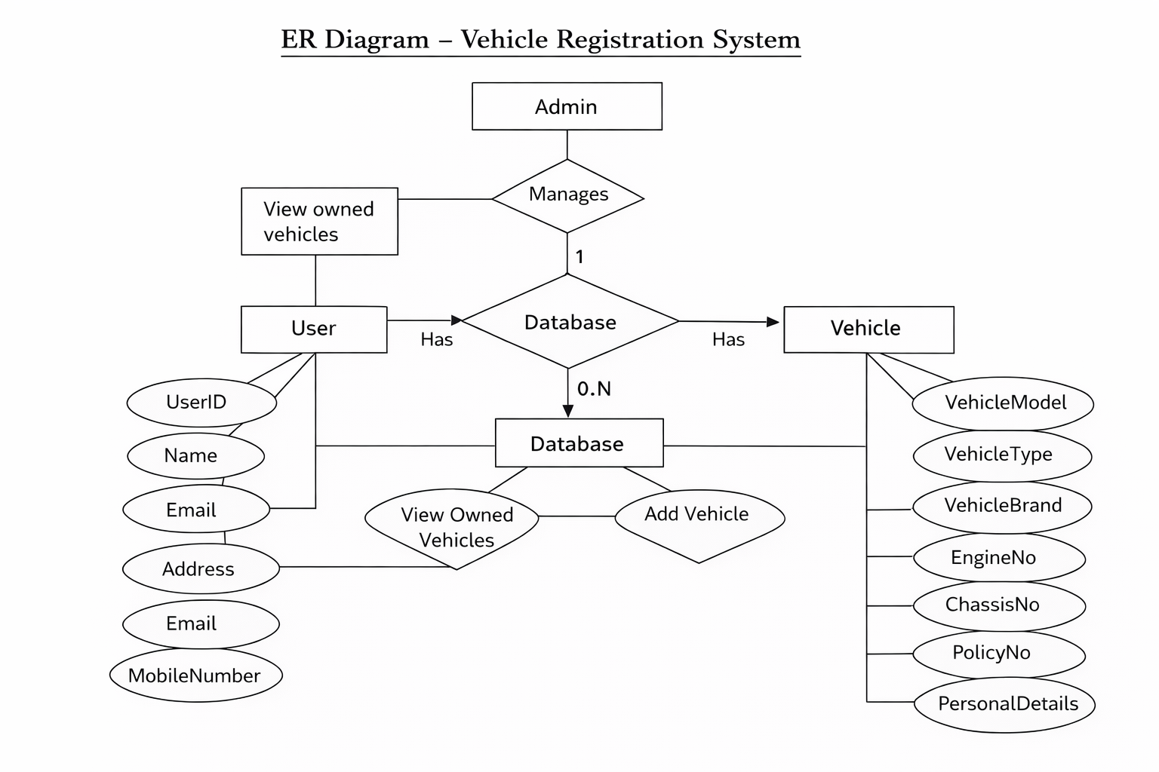

  - DATABASE DESIGN
User Data:
This store User personal and login details.
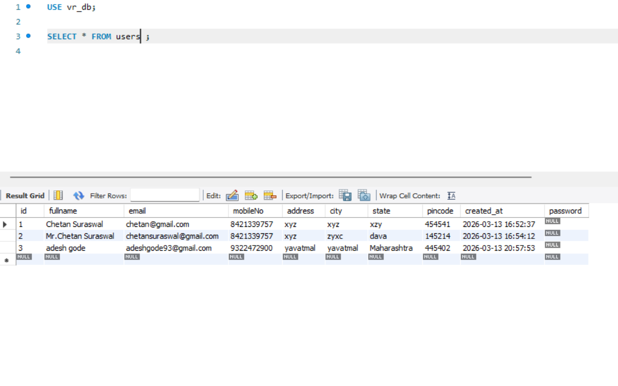

Vehicle Data:
This table store Vehicle data
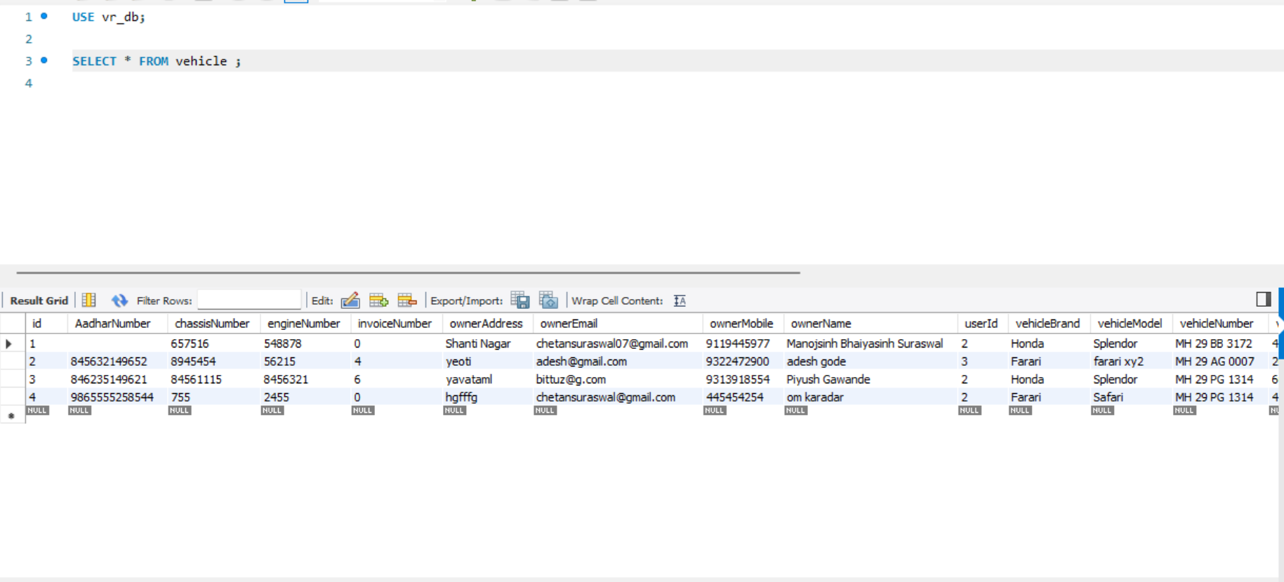

DESIGN DOCUMENT

Sign In Page :
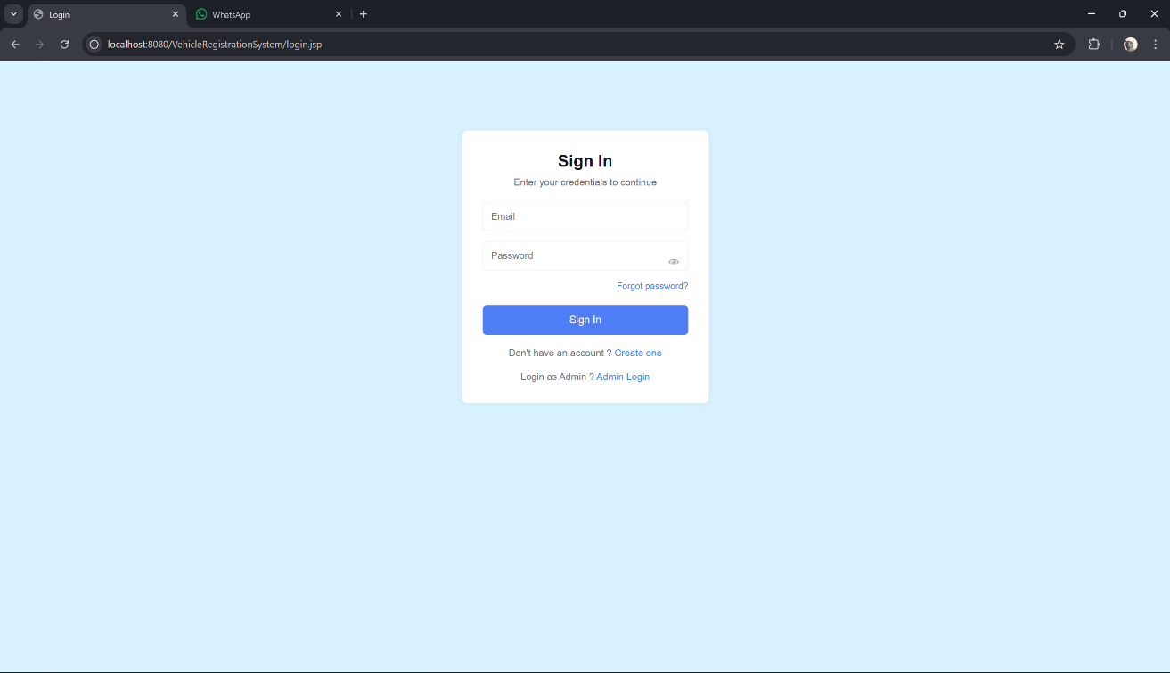

Sign Up Page :

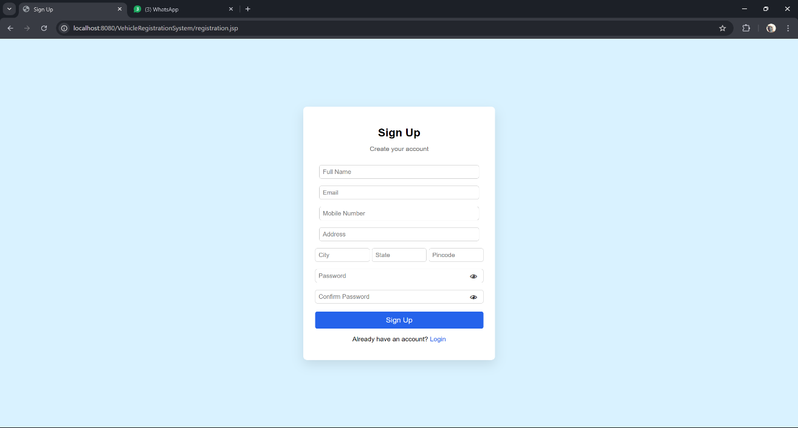

Profile Page :
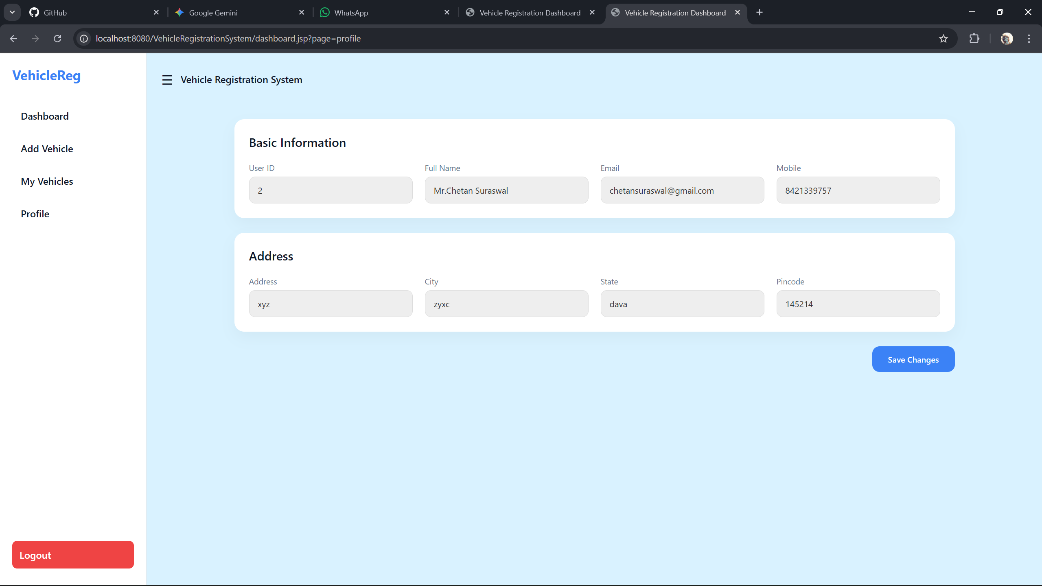

My Vehicle Page :
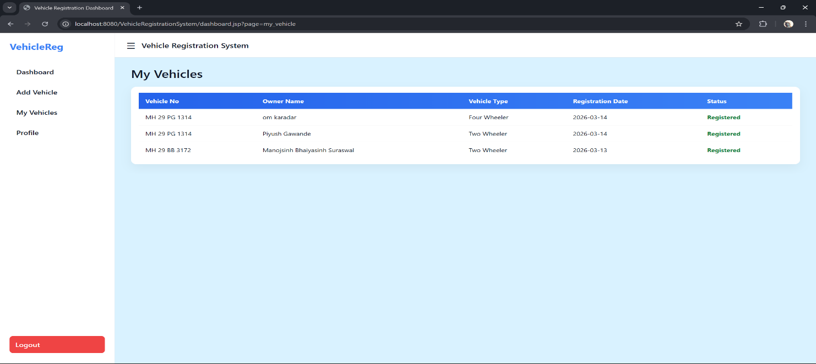

Vehicle Registration Form : 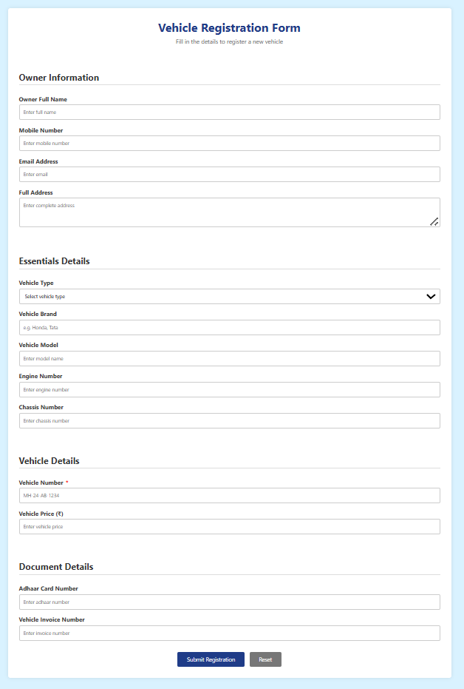

Dashboard :
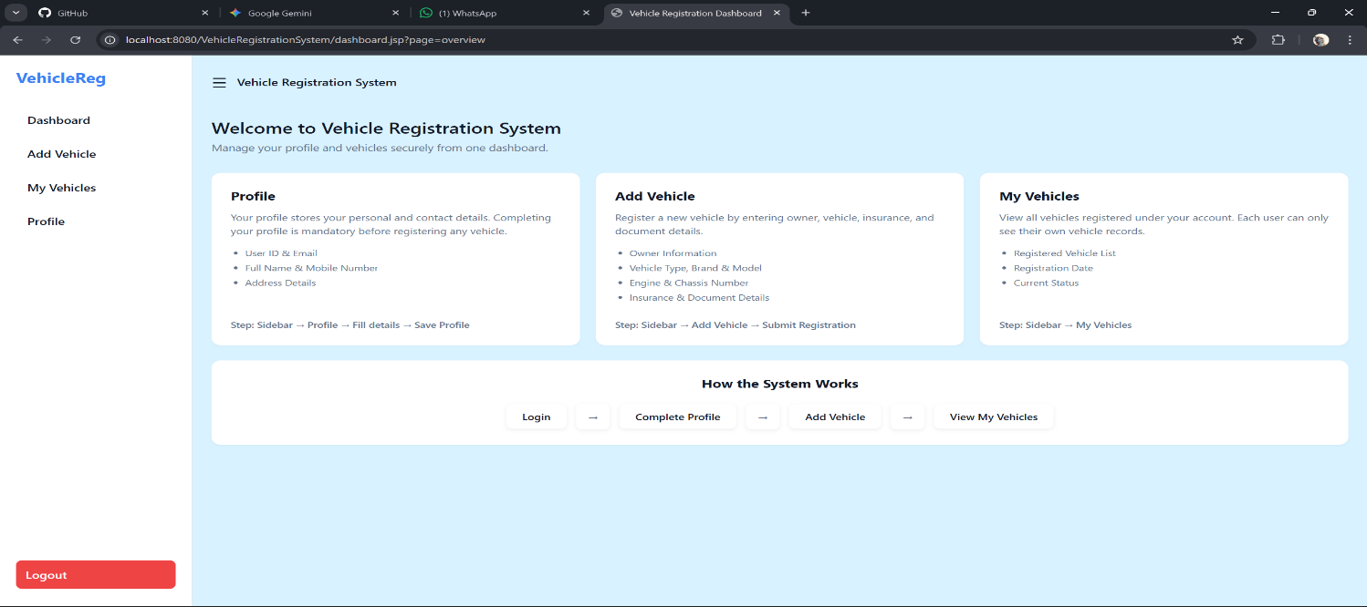

Forgot Password :
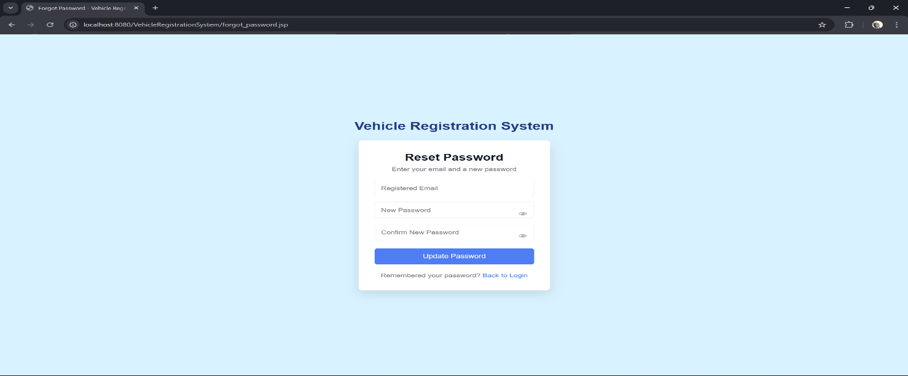

Admin Sign In :
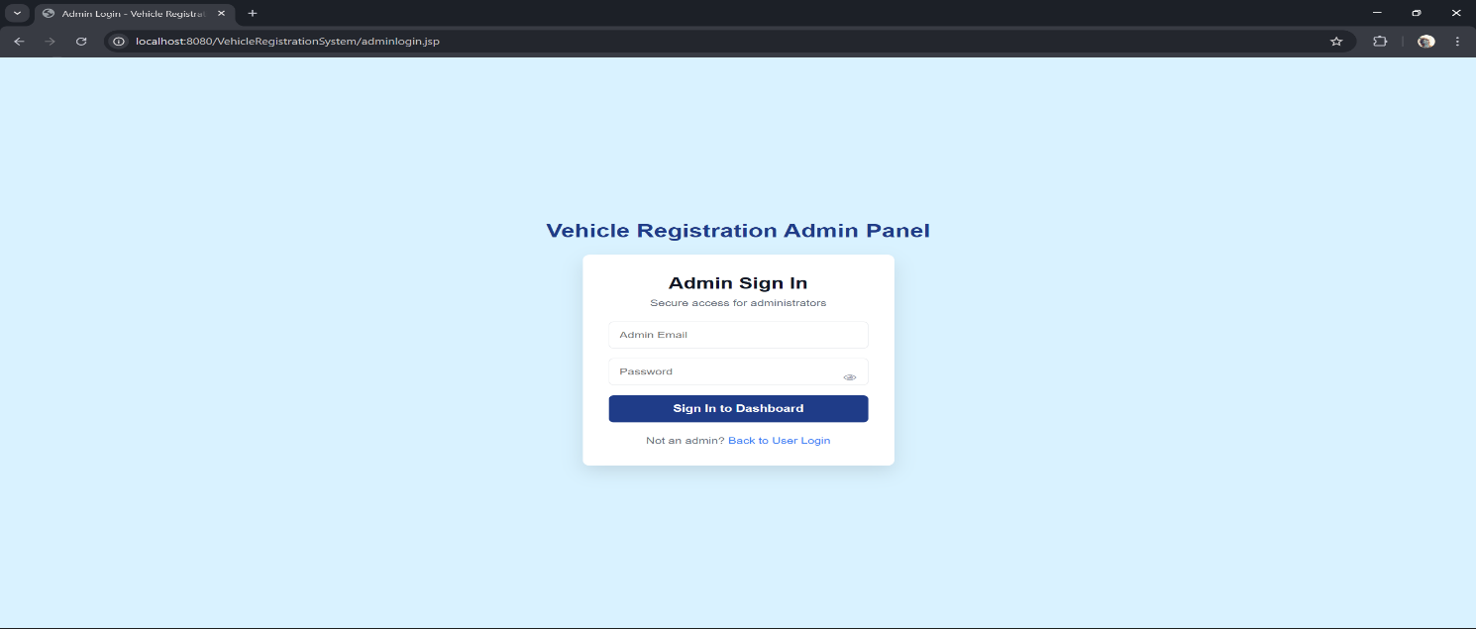

Admin Dashboard :
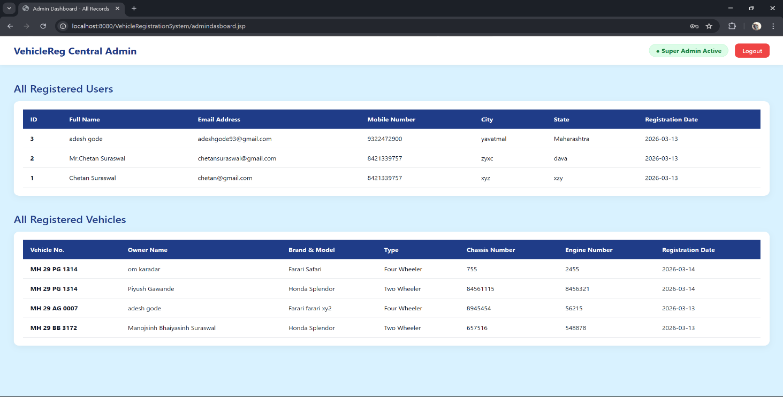

SYSTEM TESTING AND
IMPLEMENTATION

Software Testing

The goal of the system testing process was to identify faults in our Vehicle Registration System project. The program was tested using different inputs and the results were analyzed to determine whether the system behaved as expected. Our project went through two levels of testing.

- Unit testing
- Integration testing

UNIT TESTING

Unit testing is performed when a module is developed and reviewed. To test a single module, a proper environment is required which includes the supporting procedures and data structures needed that module

  - Procedures belonging to other units that the module calls
  - Non-local data structures that the module accesses
  - A procedure to execute the functions of the module with proper parameters

Test for the admin module

  - Testing admin login form-This form is used for administrator login. The admin enters a username and password; if the details are correct the dashboard opens, otherwise the system redirects back to the login page and asks for correct credentials.
  - Vehicle Record Management: The admin can add, update, search, and delete vehicle records stored in the database.

INTEGRATION TESTING

In integration testing, different modules of the project are tested together by providing input. The main objective is to verify the interaction between modules and ensure that no errors occur when one module communicates with another module.

FUTURE SCOPE AND
LIMITATION

Scope

The Vehicle Registration System project is developed as a digital application used to manage vehicle registration records efficiently. The purpose of developing this system is to store and manage vehicle information without relying on manual paperwork. Another purpose of this application is to maintain vehicle records in a structured database and generate reports when required.
The scope of the Vehicle Registration System includes the development of a centralized platform designed to simplify the process of storing, updating, and retrieving vehicle registration information. The system improves record management by providing a user-friendly interface for administrators to add new vehicle details, search existing records, update information, and manage the database. It also supports organized data storage and quick access to vehicle details whenever required.

Limitations

- System Dependency: The application depends on a computer system, so hardware or software failures may affect system operation.
- Limited Access: Only authorized administrators can manage vehicle records, restricting direct access for other users.
- Data Security: Vehicle and owner information must be protected properly to prevent unauthorized access or misuse.
- Initial Setup Effort: Implementing the digital system requires initial setup, configuration, and data entry before regular use.

CONCLUSION

CONCLUSION

The Vehicle Registration System is a comprehensive digital application designed to simplify the management of vehicle registration records. The system provides several important features such as administrator login, vehicle record management, data storage, and report generation. The system is developed using modern technologies and is designed to replace traditional manual record-keeping methods. While the system offers many benefits such as improved efficiency and organized data management, it may also face some limitations such as system dependency and the need for proper data security.

The Vehicle Registration System provides an efficient solution for maintaining vehicle records in a structured and centralized database. By digitizing the registration process, the system helps administrators easily add, update, search, and manage vehicle details. This reduces paperwork, minimizes human errors, and improves the overall efficiency of record management.

In conclusion, the Vehicle Registration System provides a reliable and modern solution to the challenges faced in traditional vehicle record management. The system ensures that vehicle information is stored securely and can be retrieved quickly whenever required. It also improves administrative operations by providing an organized platform for managing vehicle data. Overall, the system enhances accuracy, saves time, and supports better management of vehicle registration information through a centralized and efficient digital system.

REFERENCE AND
BIBLIOGRAPHY

REFERENCE AND BIBLIOGRAPHY

1.Pressman, R. S., Software Engineering: A Practitioner’s Approach, 8th Edition, McGraw-Hill
Education, 2014

2. Raghavan, S., & Kumar, A., “Web-Based Vehicle Registration System Design and Implementation, Journal of Software Engineering and Applications, 2019.

- Laudon, K. C., & Laudon, J. P., Management Information Systems: Managing the Digital Firm, 15th Edition, Pearson Education, 2020.

- Sommerville, I., Software Engineering, 10th Edition, Pearson Education, 2015.

- Kothari, C. R., Research Methodology: Methods and Techniques, 2nd Edition,
New Age International Publishers, 2004.

- Sharma, R., “Design and Development of Vehicle Registration Management System,” International Journal of Computer Applications, Vol. 179, No. 25, 2018.

- Government of India – Ministry of Road Transport & Highways, “Motor Vehicle Registration and Information System,”

- https://www.who.int

- Stack Overflow, “Database Design and Authentication in Applications,”
https://stackoverflow.com

3.Tutorials Point, “Application Development using HTML, CSS and JavaScript,”
https://www.tutorialspoint.com

4.Geeks for Geeks, “Vehicle Registration System – Application Project,”
https://www.geeksforgeeks.org

